2022

James Caroe

UTc OLP

Unit 2 LO1

Contents

L01 2

Ideas Development & Audience 2

Technical Aspects 4

Sound 4

Images 4

Videos 5

Design Aspects 5

Design Outline 8

# L01

# Introduction

I have been asked to create a product for Kelham Island Museum. I will be considering a few different options for my product and will be making my own assets. I have conducted research into other museum’s products so that I can make my product as good as possible.

## Ideas Development & Audience

**Animation of steam engine running**  
An 3d model would be useful to explain how the River Don Steam Engine works. An animation would be good for all ages because anyone can look at a model, and an be quite easy to understand.

Some models could be made in blender and imported into unity to make an animation of the steam engine running, so people can look at the engine without it having to run which takes a long time to set up.  
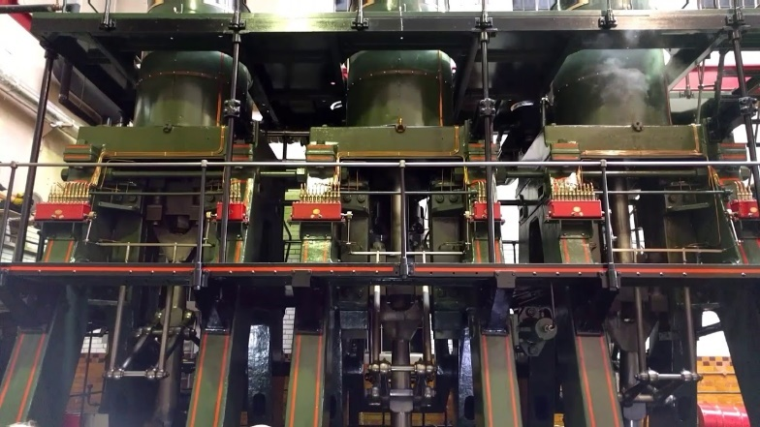

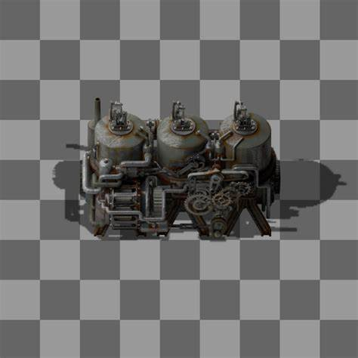

**360﮿ virtual tour**A 360 virtual tour could be a fly through or a series of 360 images. This would enable people to “visit” the site without physically going there. This would be useful because people could look around in all directions. This would be more targeted towards teenagers and young adults because younger and older people could struggle to operate the product.  
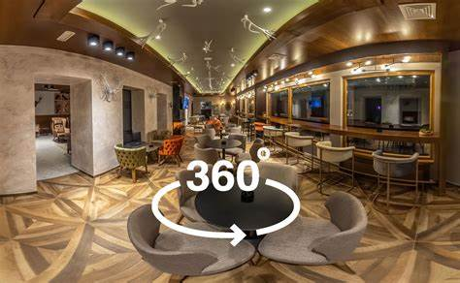

**VR tour**A virtual reality tour would be good so that people can look around the site without physically going there. But not everyone has a VR headset, so it isn’t quite as accessible as a 360 tour. This would be targeted towards teenagers and young adults. Children’s heads are too small to use a VR headset. And older adults may not want to use it.

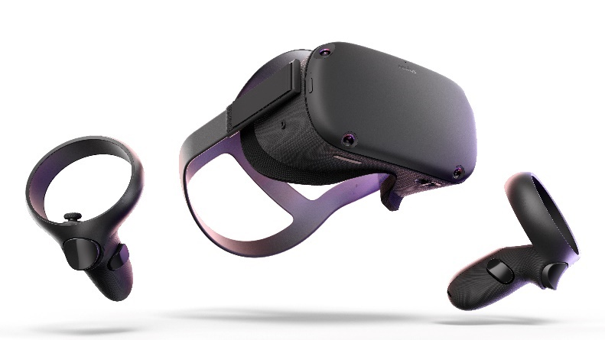

**RFID Tag activated tour**

A tour that changes activated by short range RFID tags would be useful because the user can just have the information about the site appear on their phone without looking for it in the room. This would be suitable for teenagers or older, because younger people may not have a mobile device, and if they did, then they may not be able to use it.

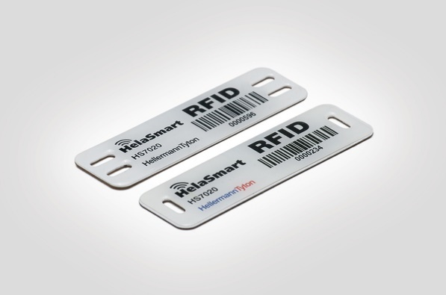

All these projects have their own advantages, an animation would be good for all ages, but may be a bit simple. A 360 tour is very useful but may be harder to access for everyone. A VR tour is very entertaining for some people, but the headset might not fit everyone, and they might not be able to use it. An RFID tag would be good for a further tour, but some people with older phones may not have a RFID reader in their phone.

## Technical Aspects

### Sound

|  |  |
| --- | --- |
| .MP3 | MP3s are compressed using lossy compression, they lose a lot of data and can be very bad sound quality. They are good for use online because they are a very small file, so they can be quick to download online.  I would use MP3s in a mobile RFID app because they load quickly when needed because of their small file size. A file that takes too long to load wouldn’t be good and the user may lose interest in the product. |
| .WAV | WAV files are uncompressed files, they are the equivalent of BMP files. They lose no data and have very good sound quality. They are good for local files that don’t need to load quickly because they are very large files.  I would use WAVs in a VR animation, because they are uncompressed, and they don’t lose any data. They also have very high audio quality, so they would make a good experience for the user. |
| .FLAC | FLACs are compressed using lossless compression, they are smaller files than WAVs but bigger than MP3s. They have good sound quality because they lose no data.  I would use FLACs in a virtual tour because they have good audio quality, but still are compressed so they can be loaded relatively quickly. |

### Images

|  |  |  |  |
| --- | --- | --- | --- |
| File Type | Description | | Example |
| .JPG | .JPG files are very compressed. They are compressed using lossy compression which means they lose data forever. They have much worse quality compared to other uncompressed files. These are best for making websites, because they load quickly. I would use JPGs in a RFID tag tour because they are very quick to load and don’t take up much space. | | The Swift Programming Language |
| .PNG | .PNG files are compressed using lossless compression. They have relatively good quality compared to other compressed image files. PNGs are best for using when making mobile apps. Because mobile apps mostly only support PNGs. I would use PNGs in a virtual tour because they need to be high quality, but also relatively small. | | See the source image |
| .BMP | .BMP (Bitmap) files are totally uncompressed files. They map each individual pixel to their position in the image. Their quality is extremely good. I wouldn’t use BMPs in any product because they are too large to be practical. I would only use one when printing. | |  |
| .GIF | .GIF files are very small and low quality. They are good for small animations. These are used for things like animated logos. I would only use a gif for a small, animated images. I would use them in a mobile app or online. |

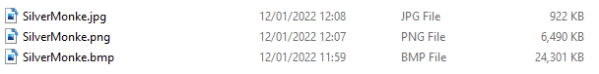

### Videos

|  |  |
| --- | --- |
| File Type | Description |
| .MP4 | MP4s is a very popular format for videos because they are heavily compressed, so they don’t use up much space. However, the quality of the video is not very good, and so it is bad if you want to keep quality in a video. They are good for using online, so that they load quickly. MP4s are very easily used across all devices. They are cross compatible with lots of things. I would use MP4s for |
| .AVI | AVIs is a format used when you want to keep the quality of the video high, they don’t compress the video, so it keeps the original quality. However, that means that they take up a lot of storage space. AVIs are good for large displays that store the file on a hard drive, so there is not transfer of data online. AVIs need the right things installed to be able to play them, so they’re not particularly cross compatible. |
| .MOV | MOVs are created for Apple devices, they cannot be played on other devices without a separate app to play it. It is large compared to AVIs, because it is less compressed. |

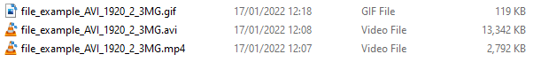

## Design Aspects

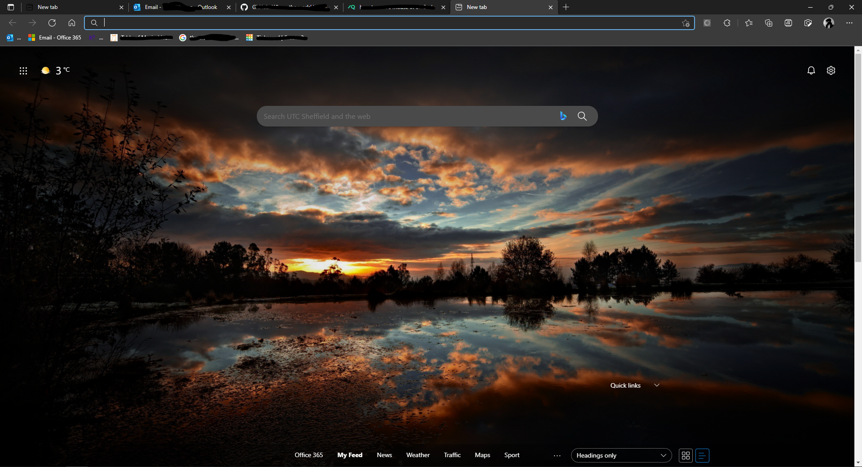

Edge has very dark colours in dark mode, this is because the user has chosen to make the colour scheme. These colours may have a neutral and calming effect.

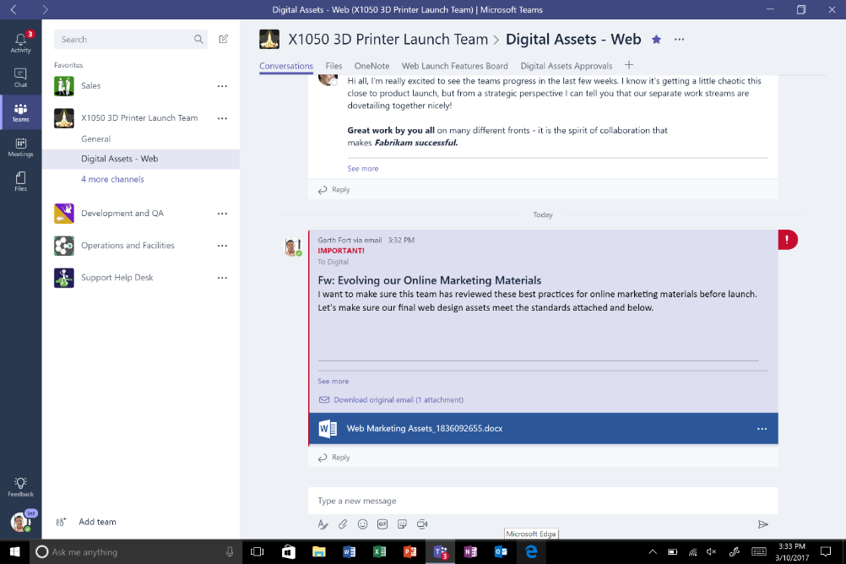

Teams has a blue and white colour scheme which may create a sense of professionalism and focus. Teams also uses the rule of thirds which makes a product look more engaging. The menu at the left is a third of the screen, and the messages on the right take up two thirds

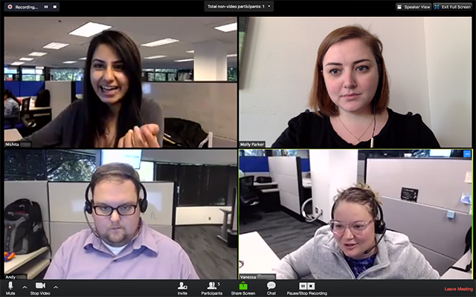

Zoom has a very dark colour scheme which is very neutral and doesn’t inspire much emotion within a user.

Red is a warm colour, it can inspire colour, passion, love, and anger. In marketing it is used to create urgency, increase heart rate.

Orange is energetic, it is happy and creates excitement. It is good for calls to action.

Yellow is a contradictory colour. It can create happiness and hope, but it also signifies danger and deceit in nature.

Blue is used in businesses because it inspires strength, reliability, cleanliness, and purity. It is also a calming colour.

Using the right colours is important to give the right impression to the reader. If a product doesn’t have the right colours, it can throw off the user, and make them not want to use the product. A good layout is also very important for engaging a user in a product.

This is a colour scheme I might use for a potential interactive media product. They are not too dark, but still bright, they are engaging but not overly bright.



Different fonts display different ideas:

Testing font – This font is an example of a display font, and it would be used for decoration

Testing font – This is an example of a serif font; this can be used for general content for a product

Testing font – This is an example of a sans serif font, this can be used for general content for a product, but to try and keep the product simple.